Euler Angles
The most commonly used sets of attitude parameters are the Euler
angles. They describe the attitude of a reference frame B relative to the
frame N through three successive rotation angles (01 , 02, f)3) about the
sequentially displaced body-fixed axes {b}.
he order of the axes
about which the reference frame is rotated is important here. Performing
three successive rotations about the third, second, and firs
these sequential rotations provide
an instantaneous geometrical recipe for N. Clearly, for B undergoing a
general motion, the 0i(t) are time varying in a general manner.
Aircraft and spacecraft orientations are commonly described
Aircraft and spacecraft orientations are commonly described through the
Euler angles yaw, pitch, and roll (t/1, 0, </)) a
They are usually
measured relative to axes associated with a nominal flight path. The position
A
of {b} relative to {n} is described by a sequence of three rigid rotations about
prescribed body-fixed axes.
To transform components
of a vector in the N frame into the B frame through a sequence of Euler
A
angle rotations, the reference axes are first rotated about the b3 axis by the
A
yaw angle t/J, then about the b2 axis by the pitch angle 0, and finally about
A
the b1 axis by the roll angle </), as is shown in Fig. 3.3. Thus the standard
yaw-pitch-roll (t/1, 0, </)) angles are the (3-2-1) set of Euler angles [11].
Another very popular set of Euler angles is the (3-1-3) set of Euler angles.
These angles are commonly used by astronomers to define the orientation of
orbit planes of the planets relative to the Earth's orbit plane [l]. Whereas the
(3-2-1) Euler angles are considered an asymmetric set, the (3-1-3) Euler
angles are a symmetric set because two rotations about the third body axis
the
(3-1-3) Euler angles are known, in orbit mechanics, as the longitude of the

are performed. Instead of being called yaw, pitch, and roll angles, the
(3-1-3) Euler angles are known, in orbit mechanics, as the longitude of the ascending node fl, inclination i, and argument of the perihelion w and are

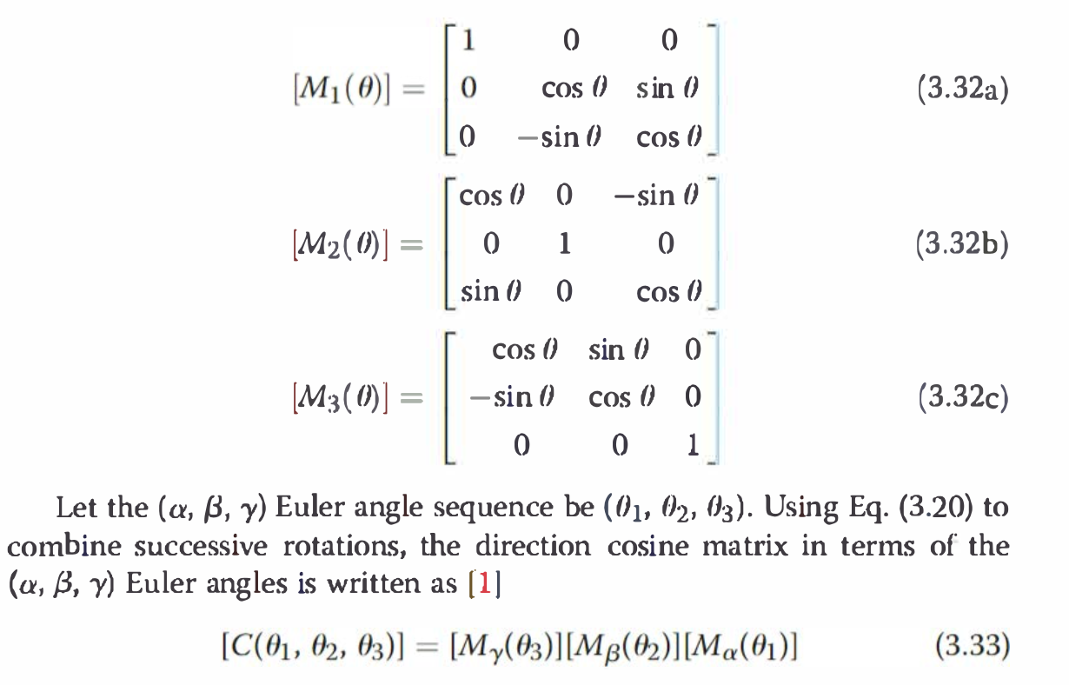

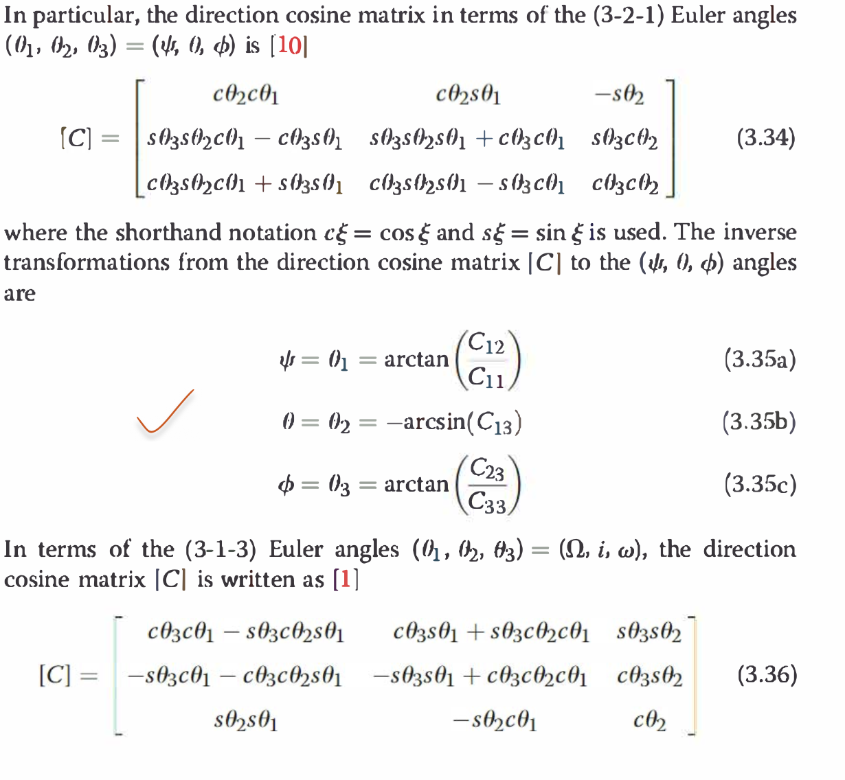
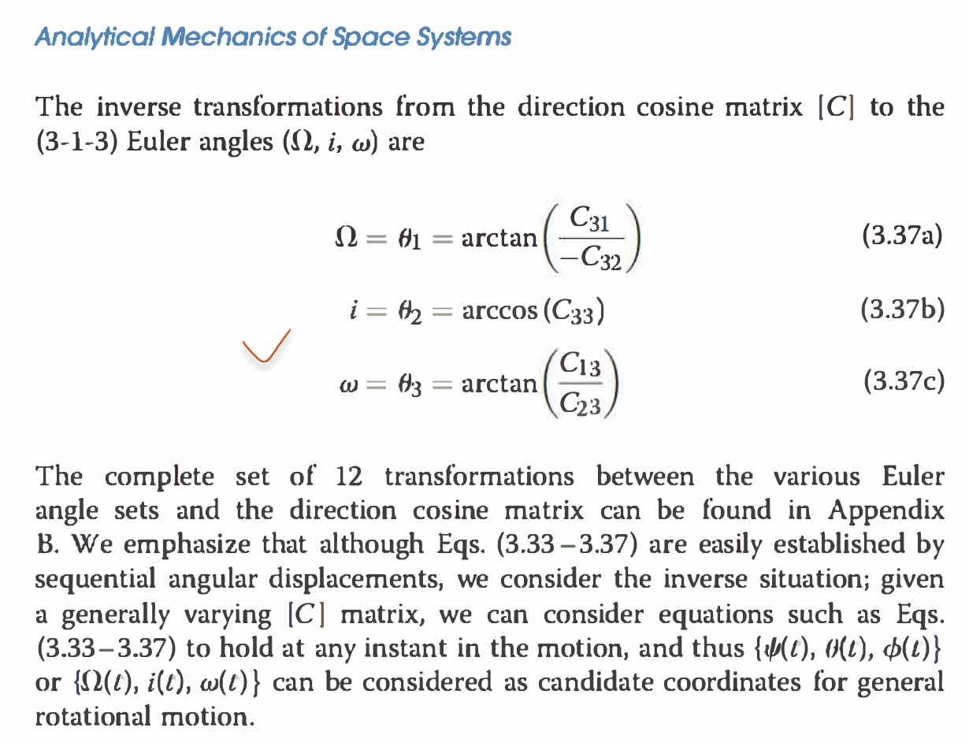

Note that each of the 12 possible sets of Euler angles has a geometric
singularity where two angles are not uniquely defined. For the (3-2-1)
Euler angles, pitching up or down 90 deg results in a geometric singularity.
If the pitch angle is + 90 deg, then it does not matter if 1/J = 0 and
<P = 10 deg or 1/J = 10 and <P = 0 deg. Only the sum 1/J + <P is unique in
this case. For the (3-1-3) Euler angles, the geometric singularity occurs for
an inclination angle of O or 180 deg. This geometric singularity also manifests
itself in a mathematical singularity of the corresponding Euler angle kinematic
differential equation.
Let fJ = {01, 02, 03} and cf,= {¢1, ¢2, </,3} be two Euler angle vectors
with identical rotation sequences. Often it is necessary to find the attitude
that corresponds to performing two successive rotations, i.e., "adding" the
two rotations. If a rigid body first performs the rotation fJ and then the
rotation cf,, then the final attitude is expressed relative to the original attitude
through the vector 'P = { cp1, 'P2, cp3} defined through
[FN('P)] = [FB(cp)][BN(O)] (3.38)
Equation (3.38) could be used to solve for 'P in terms of the vector components
of cf, and 0. 'This process is very tedious and typically does not
provide any simple, compact final expressions. However, for the case in
which O and <f> are vectors of symmetric Euler angles, then it is possible to
obtain relatively compact transformations from the first two vectors into
the overall vector using spherical geometry relationships

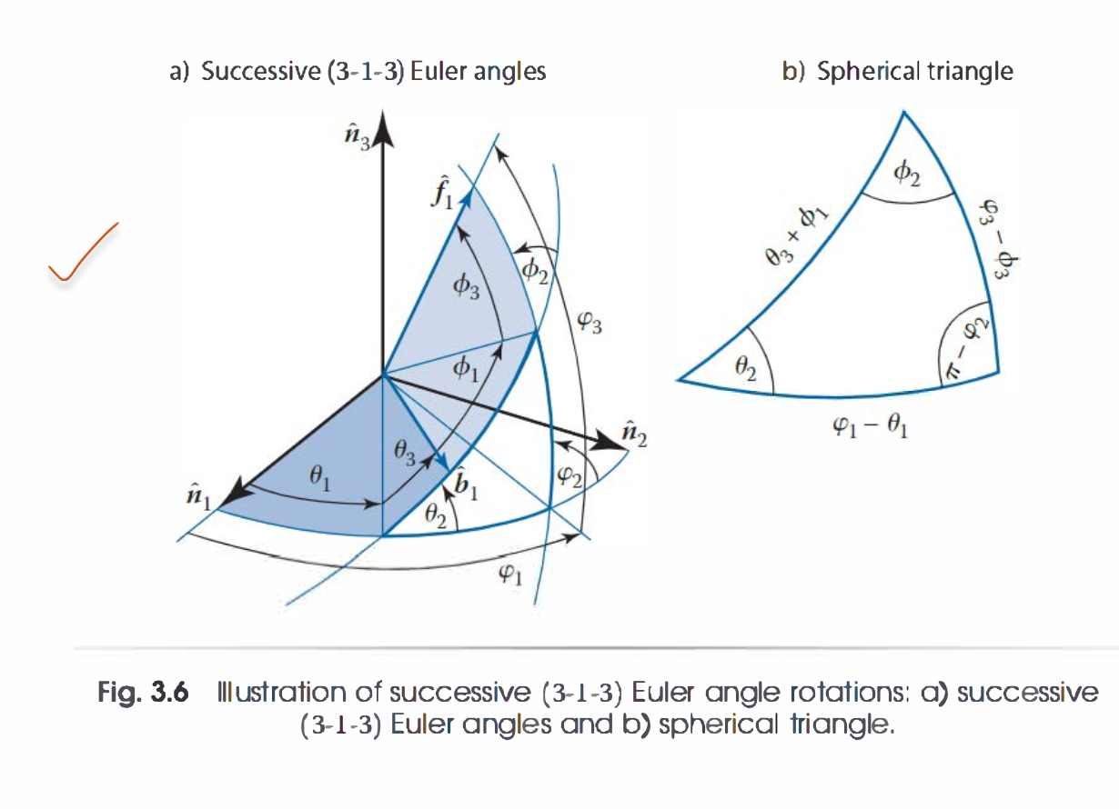
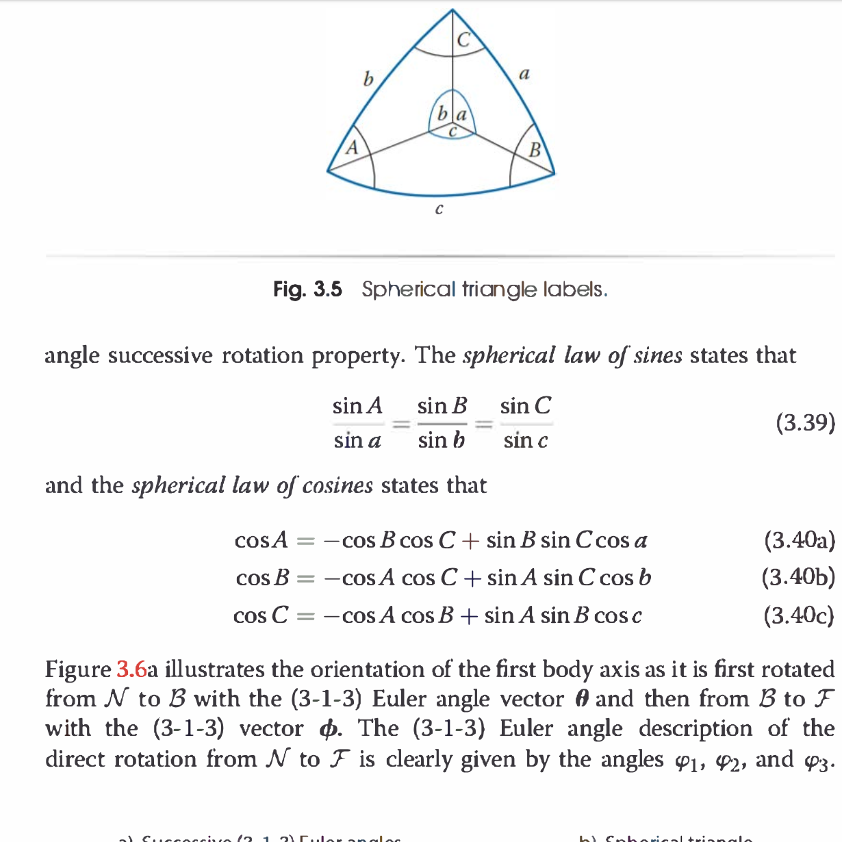

Let the vector w define the instantaneous rotational velocity of the B
frame relative to the N frame. To avoid having to integrate the direction
cosine matrix directly given an w time history, the Euler angle l<inematic
differential equations are needed. The (3-2-1) Euler kinematic differential
equation is derived in the following. The methodology can be used for any
set of Euler angles. The vector w is written in body-frame components as
A A A
w = w1b1 + w2b2 + w3b3 (3.52)
From Fig. 3.3 it is evident that the B frame rotation can also be written in
. . .
terms of the Euler angle rates (1/1, 0, </J) as
(3.53)
The unit vector b; is the direction of the body-fixed axis h2 before perform-
A A
ing a roll </J about b1, as is shown in Fig. 3.3. It can be written in terms of {b} as
(3.54)
The direction cosine matrix in terms of the (3-2-1) Euler angles in Eq. (3.34)
A
is used to express i,3 in terms of {b}:
A A A
n3 = -sin 0b1 + sin <P cos 0b2 + cos <P cos 0b3 (3.55)
After substituting Eqs. (3.54) and (3.55) into Eq. (3.53) and then comparing
terms with Eq. (3.52), the following kinematic equation is found
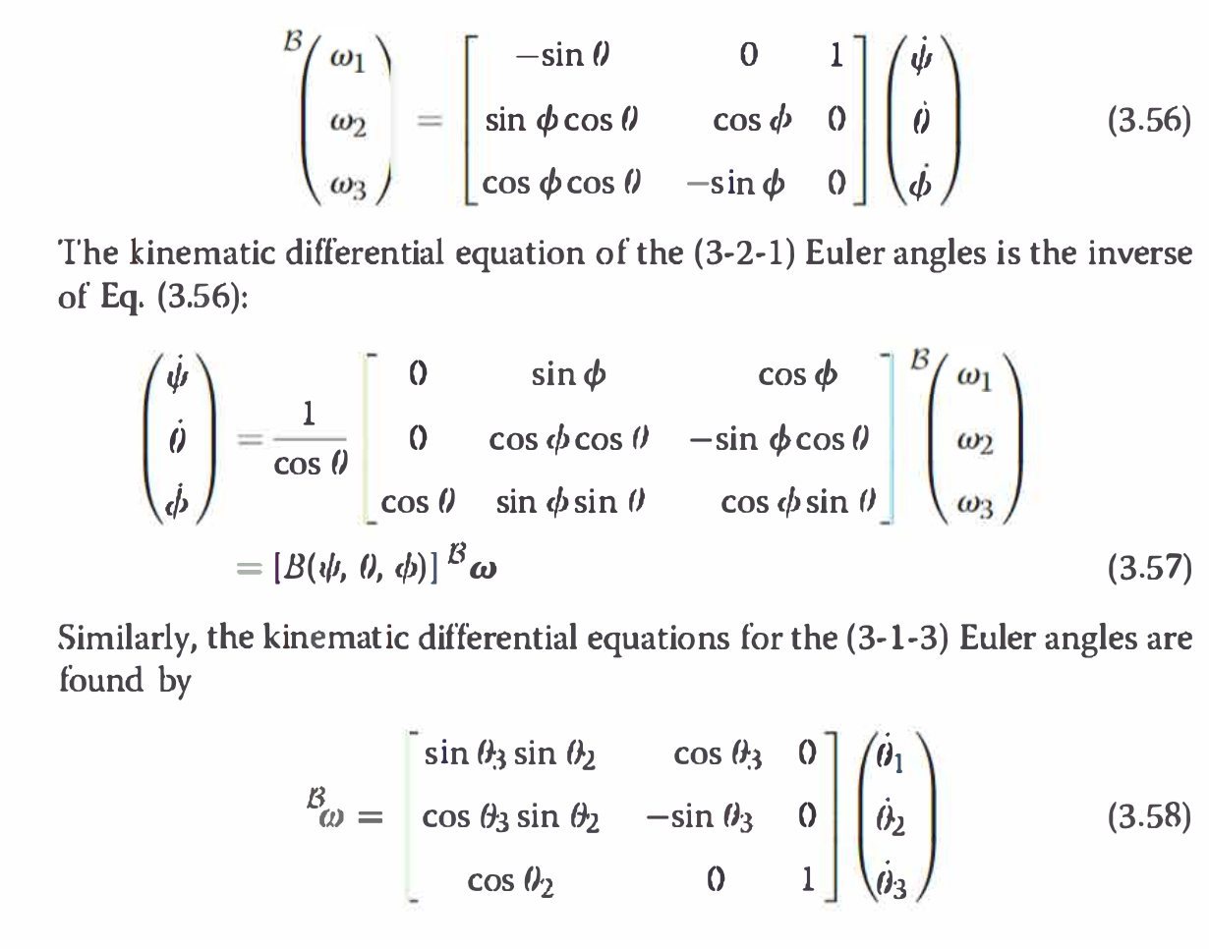

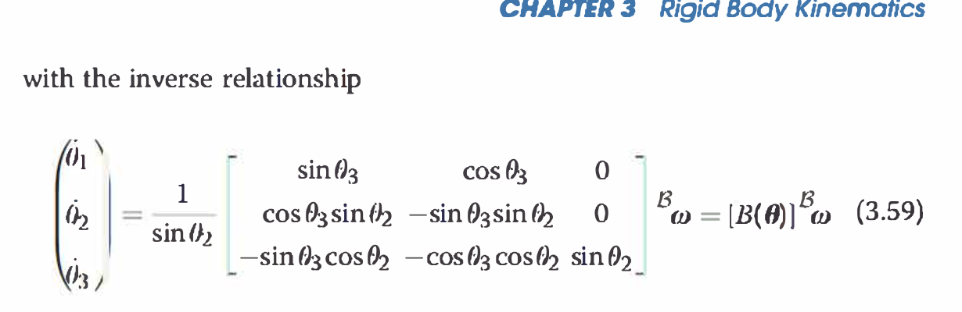

Note that the Euler angle kinematic differential equations encounter a
singularity either at 02 = + 90 deg for the (3-2-1) set or at fh = 0 or
180 deg for the (3-1-3) set. It turns out that all Euler angle sets encounter
a singularity at specific values of the second rotation angle fh only. The
first and third rotation angles f)1 and 03 never lead to a singularity. In
all cases, it can be verified that the singularity occurs for those fh values
that result in 01 and 03 being measured in the same plane. If the Euler
angle set is symmetric, then the singular orientation is at ('2 = 0 or
180 deg. If the Euler angle set is asymmetric, then the singular orientation
is ('2 = + 90 deg. Symmetric sets as the (3-1-3) Euler angles would not be
convenient to describe small departure rotations of {b} from the {n} axes
because for small angles one would always operate very close to the singular
attitude at ('2 = 0.
The Euler angles provide a compact, three-parameter attitude description
whose coordinates are easy to visualize. One major drawback of these
angles is that a rigid body or reference frame is never further than a
90-deg rotation away from a singular orientation. Therefore, their use in
describing large, and in particular arbitrary, rotations is limited. Also, their
kinematic differential equations are fairly nonlinear, containing computationally
intensive trigonometric functions. The linearized Euler angle kinematic
differential equations are valid only for a relatively small domain
of rotations.

1.2 Euler Angles
Euler angles describe the orientation of a body frame B={b1,b2,b3}B={b1​,b2​,b3​} with respect to a reference frame I={i1,i2,i3}I={i1​,i2​,i3​} using three scalar angles applied in a fixed order.
A sequence label like 3–2–1 means: first rotate about axis 3, then 2, then 1 of the current body frame. In aerospace, the most common sets are:
- 3–2–1 (yaw–pitch–roll) for aircraft and spacecraft attitude
- 3–1–3 for orbital geometry (node, inclination, argument of periapsis)

1.2.1 Rotation Sequences
Intrinsic vs extrinsic rotations
- Intrinsic sequence (used in this course):
Rotations are taken about the moving body axes. After each rotation the axes move, and the next angle is measured about the new axis orientation.
- Extrinsic sequence:
Rotations are taken about the original reference axes (fixed in space). This is equivalent to applying the inverseintrinsic sequence in reverse order.
Common aerospace sequences
- 3–2–1 sequence
  - 1st rotation: yaw ψψ about b3b3​
  - 2nd rotation: pitch θθ about the new b2b2​
  - 3rd rotation: roll ϕϕ about the new b1b1​
  - This is the standard yaw–pitch–roll description of aircraft attitude.
- 3–1–3 sequence
  - 1st: rotation ΩΩ about axis 3
  - 2nd: rotation ii about new axis 1
  - 3rd: rotation ωω about new axis 3
  - In orbital mechanics these correspond to RAAN ΩΩ, inclination ii, and argument of periapsis ωω.

1.2.2 Euler Angle Geometry
Yaw, pitch, roll
For the 3–2–1 convention:
- Yaw ψψ: heading angle; turns the body left/right in the horizontal plane.
- Pitch θθ: nose-up / nose-down tilt relative to the local horizontal.
- Roll ϕϕ: rotation about the body’s longitudinal axis (bank angle).
From Euler angles to DCM (3–2–1)
The DCM that transforms vector components from inertial II to body BB is
CIB=R1(ϕ) R2(θ) R3(ψ),CIB​=R1​(ϕ)R2​(θ)R3​(ψ),
where Rk(⋅)Rk​(⋅) is a basic rotation about axis kk. Expanding gives
CIB=[cθcψcθsψ−sθsϕsθcψ−cϕsψsϕsθsψ+cϕcψsϕcθcϕsθcψ+sϕsψcϕsθsψ−sϕcψcϕcθ],CIB​=​cθ​cψ​sϕ​sθ​cψ​−cϕ​sψ​cϕ​sθ​cψ​+sϕ​sψ​​cθ​sψ​sϕ​sθ​sψ​+cϕ​cψ​cϕ​sθ​sψ​−sϕ​cψ​​−sθ​sϕ​cθ​cϕ​cθ​​​,
with c∙=cos⁡(∙)c∙​=cos(∙), s∙=sin⁡(∙)s∙​=sin(∙).
From DCM back to 3–2–1 Euler angles
Given CIB=[cij]CIB​=[cij​]:
θ=−arcsin⁡(c13),ψ=\atan2(c12,c11),ϕ=\atan2(c23,c33).θ=−arcsin(c13​),ψ=\atan2(c12​,c11​),ϕ=\atan2(c23​,c33​).
These formulas are valid away from the singularity at θ=±90∘θ=±90∘.

1.2.3 Singularities & Gimbal Lock
Loss of one degree of freedom
- For any Euler sequence, there exists an orientation where the three angles cannot be chosen uniquely.
- At that orientation, two rotation axes line up, so the three-axis chain effectively collapses to two independent axes ⇒ the representation loses one DOF.
3–2–1 singularity at ±90∘±90∘ pitch
- For the 3–2–1 sequence, when θ=±90∘θ=±90∘:
  - Yaw and roll axes become aligned.
  - Only the sum ψ+ϕψ+ϕ is meaningful; ψψ and ϕϕ individually are not unique.
  - This is the classic gimbal lock situation.
Why quaternions avoid it
- Unit quaternions use four parameters with a unit-norm constraint instead of three unconstrained angles.
- They provide a globally non-singular attitude description: no special orientations where the parameterization breaks.
- For this reason, practical attitude estimation and control often use quaternions internally, and Euler angles only for display and interpretation.

1.2.2 Euler Angle Geometry (Extended)

A. Geometry of the 3–1–3 Euler Sequence
The 3–1–3 rotation set is widely used in orbital mechanics. The angles
(Ω,i,ω)(Ω,i,ω) correspond to:
- First rotation (about axis 3): rotate by ΩΩ to align with the ascending node.
- Second rotation (about axis 1): rotate by inclination ii to tilt the plane.
- Third rotation (about axis 3): rotate by ωω to align the periapsis direction.
Geometrically:
- The first and third angles both rotate about axes parallel to the inertial i3i3​ and final b3b3​ directions.
- The middle angle ii changes the orientation of the orbital plane—it is the only rotation not about a symmetry axis.

DCM for the 3–1–3 sequence
CIB=R3(ω) R1(i) R3(Ω)CIB​=R3​(ω)R1​(i)R3​(Ω)
Expanding gives the matrix shown in the textbook (your screenshot), mapping inertial vectors to the orbital frame.

Inverse transformation (from DCM to Ω,i,ωΩ,i,ω)
From the (3–1–3) DCM:
Ω=arctan⁡(C31−C32),i=arccos⁡(C33),ω=arctan⁡(C13C23).Ω=arctan(−C32​C31​​),i=arccos(C33​),ω=arctan(C23​C13​​).
These formulas hold away from the singularity at i=0∘i=0∘ or 180∘180∘.

B. Singularities of the 3–1–3 Sequence
For 3–1–3:
- The singularity occurs when
i=0∘ori=180∘i=0∘ori=180∘
- At these orientations, the first and third rotation axes become aligned.
- The angles ΩΩ and ωω lose uniqueness—you can change both while the overall attitude remains the same.
This is the same geometry behind the singularities of any Euler system:
when the second angle collapses the rotation triad onto a single plane, you lose one degree of freedom.

C. Adding Two 3–1–3 Rotations (Sequential Euler Rotations)
Sometimes a rigid body performs two separate sets of Euler rotations:
- First rotation: θ={θ1,θ2,θ3}θ={θ1​,θ2​,θ3​}
- Second rotation: ϕ={ϕ1,ϕ2,ϕ3}ϕ={ϕ1​,ϕ2​,ϕ3​}
The combined attitude is:
C(ψ)=C(ϕ) C(θ)C(ψ)=C(ϕ)C(θ)
where ψ={ψ1,ψ2,ψ3}ψ={ψ1​,ψ2​,ψ3​} is the single equivalent set of Euler angles for the same rotation.

Key points:
- For a general asymmetric sequence (e.g., 3–2–1), extracting ψψ from the product is messy and usually not expressible in compact closed form.
- For symmetric sequences like 3–1–3, spherical triangle identities provide simplified formulae.
- Even with symmetry, the resulting expressions tend to be algebraically complicated, which is why numerical attitude representations (quaternions, DCMs) are preferred for rotation chaining.
Interpretation:
Euler angles are intuitive for interpretation, but not for combining rotations.

D. Euler Angle Kinematic Differential Equations
Given body angular velocity
ω=(ω1,ω2,ω3)ω=(ω1​,ω2​,ω3​)
expressed in the body frame, we want to convert ω(t)ω(t) into rates of Euler angles.

1.3–2–1 Differential Equation (summary)
The 3–2–1 Euler kinematics relates angle rates (ϕ˙,θ˙,ψ˙)(ϕ˙​,θ˙,ψ˙​) to body rates (p,q,r)(p,q,r):
[pqr]=[10−sin⁡θ0cos⁡ϕsin⁡ϕcos⁡θ0−sin⁡ϕcos⁡ϕcos⁡θ][ϕ˙θ˙ψ˙]​pqr​​=​100​0cosϕ−sinϕ​−sinθsinϕcosθcosϕcosθ​​​ϕ˙​θ˙ψ˙​​​
This comes directly from expressing angular velocity in two ways:
- As a physical vector in the body frame
- As a combination of instantaneous rotations associated with changing Euler angles
Comparing the two expressions yields the kinematic relation.

Singularities in kinematic equations
The matrix becomes singular when:
- 3–2–1:
θ=±90∘θ=±90∘
- 3–1–3:
i=0∘or180∘i=0∘or180∘
In each case, the coefficient matrix loses rank and the system cannot be inverted.

E. Practical Limitations of Euler Angles
- Every Euler set has at least one singular orientation where the parametrization fails.
- A rigid body is always within 90° of a singular state for any Euler convention.
- The kinematic differential equations contain nonlinear trigonometric functions, making them less efficient for real-time attitude propagation.
- For small rotations, symmetric sequences like 3–1–3 are especially inconvenient because the working attitude lies close to the singularity.
Therefore:
Euler angles remain useful for human interpretation, but numerical propagation and control rely on quaternions or DCMs.

